

VA BTSSS - Travel Pay - Simple, Mileage-Only, Claims (SMOC)

April 1, 2025 | Travel Pay - SMOC

Version 2.0

Revision History

| Date | Version | Description | Author |
| --- | --- | --- | --- |
| 04/01/2024 | 1 | Initial Release Version | Ayush Chakravarty |

Table of Contents (**CUSTOMIZE AS NEEDED**)

**1. Product Overview 4**

**2. User Access 5**

**3. Navigation 5**

**4. Functionality 6**

**5. Major Issues and Error Messages 6**

## 1. Product Overview

Simple, Mileage-Only Claims is the first iteration that enables users to submit travel claims on VA.gov where they traveled in their own vehicles to and from their VA medical appointments. Users can see their list of past appointments and click the “details page.”

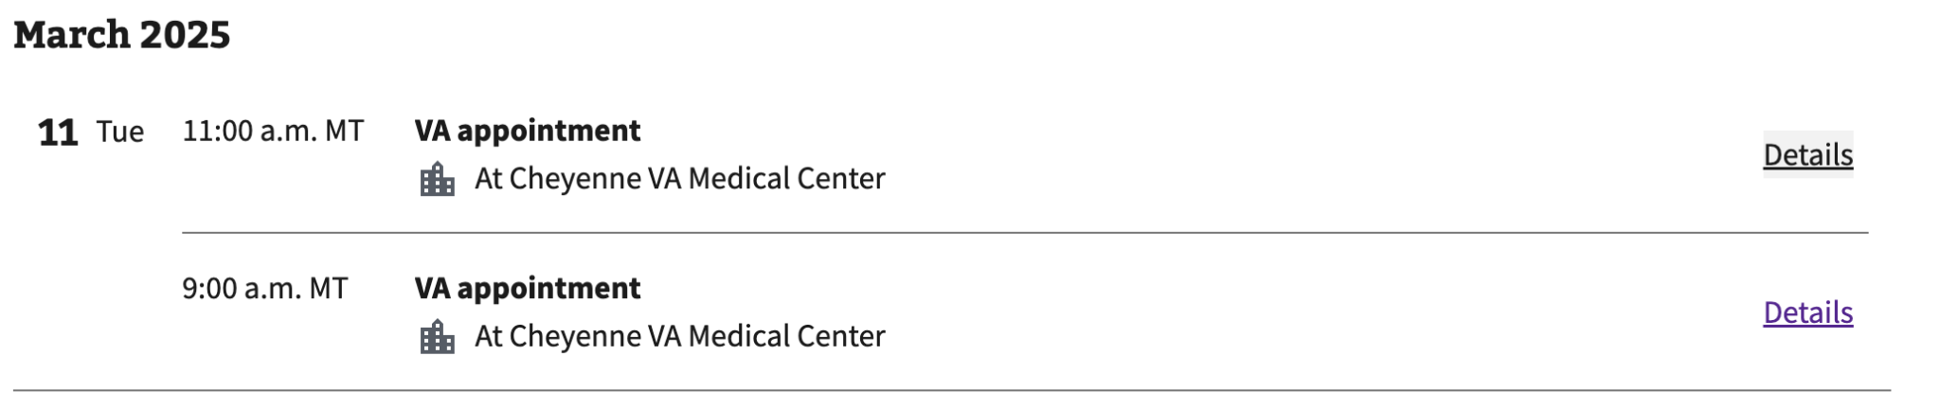

## 2. User Access

Users must be authenticated to access Simple, Mileage-Only Claims on VA.gov. Users also must have at least one past appointment for which to file a travel claim.

## 3. Navigation

* Users can access SMOC through <https://va.gov/health-care/file-travel-pay-reimbursement/> at the widget on the page.

*Unauthenticated view*

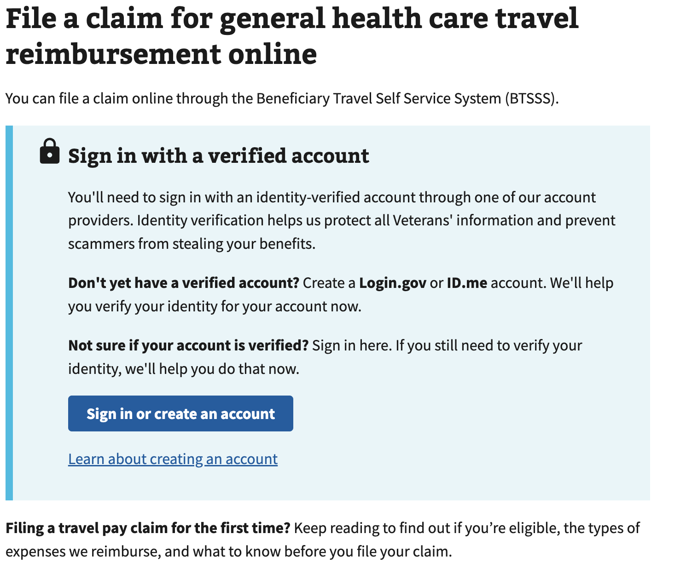

*Authenticated view*

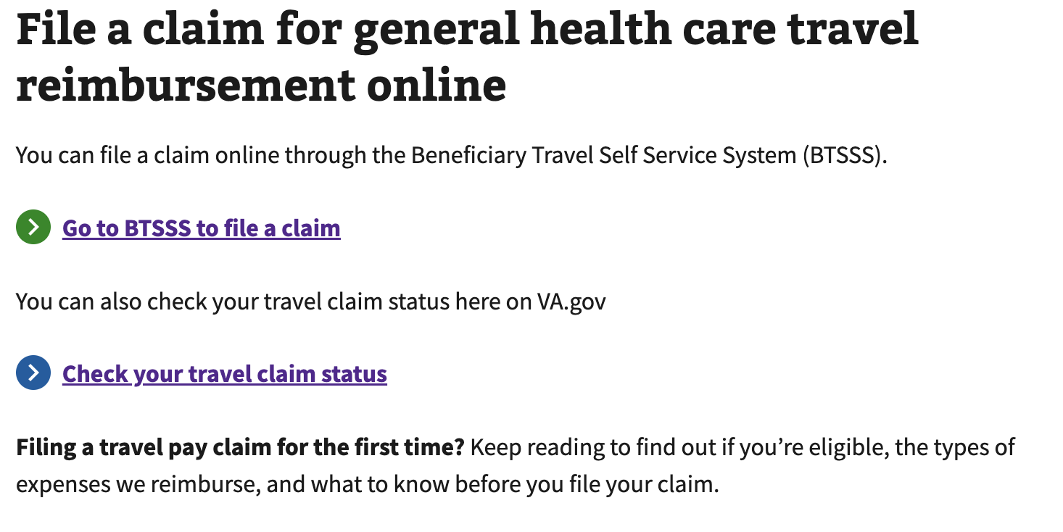

* Users can also access SMOC from their past appointments list (discussed further in the next section):

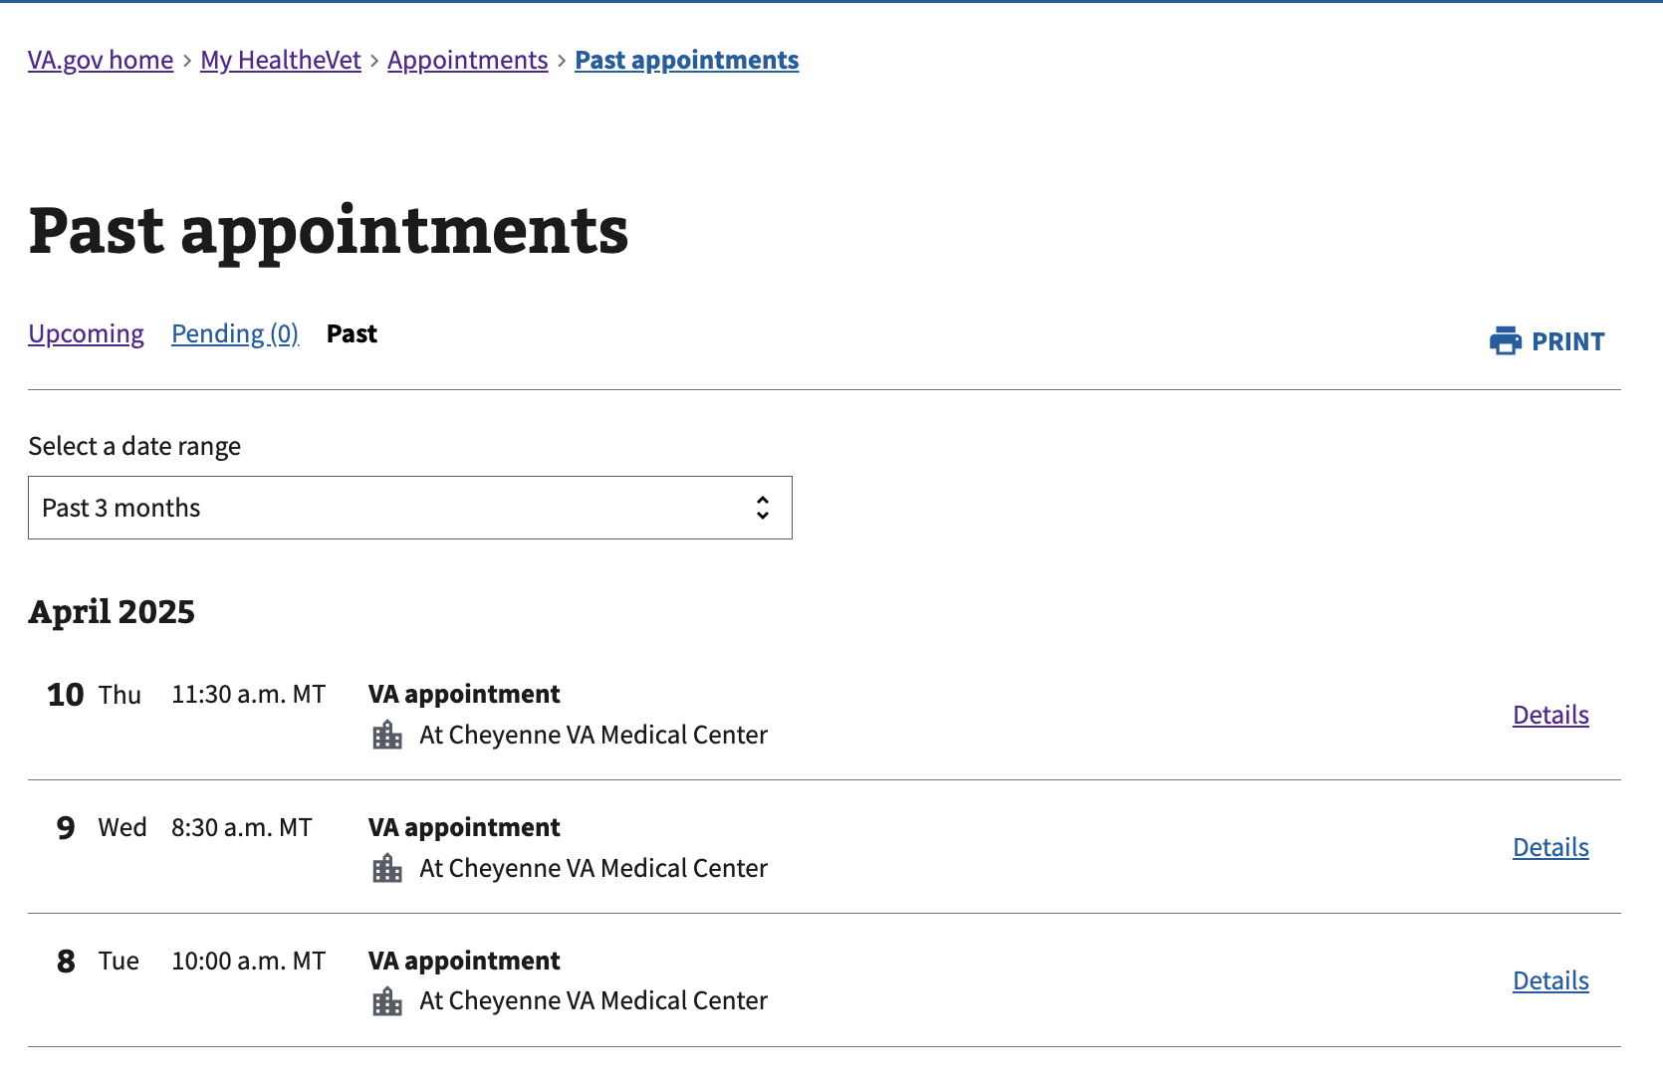

## 4. Functionality

1. SMOC enables users to follow a single, multi-step flow where they select questions to answer and file for reimbursement as long as all questions are answered with a “yes.”
2. Users are taken to a list of past appointments where they can click “details” to open up additional information about their past appointment.



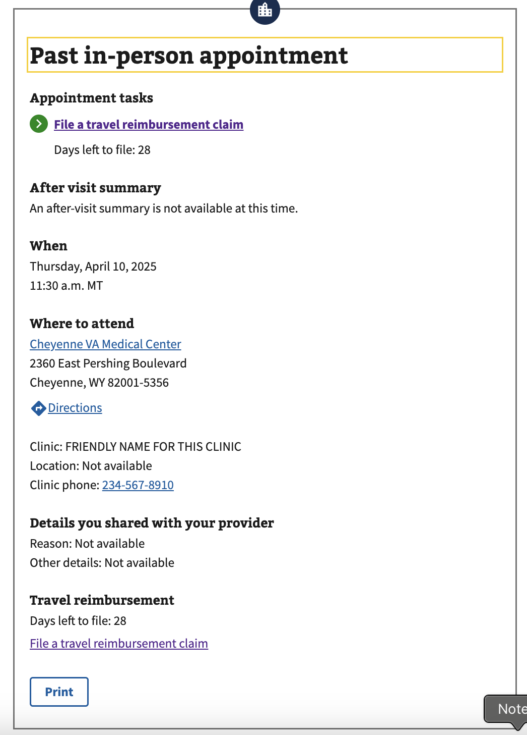

1. They can then click “file a travel reimbursement claim,” which will take them into the SMOC flow. If they click into the flow, it will ask them the following questions:

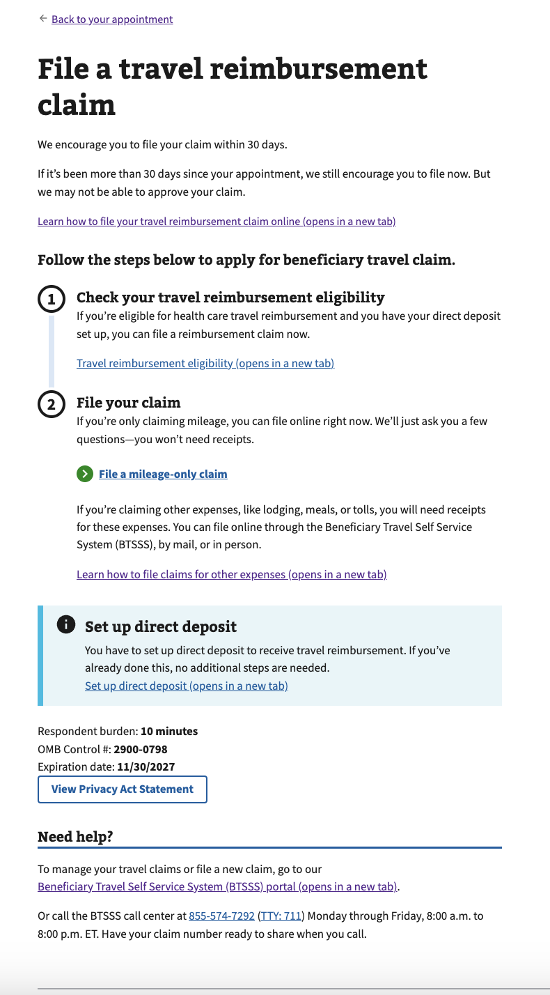

* + Are you claiming only mileage?

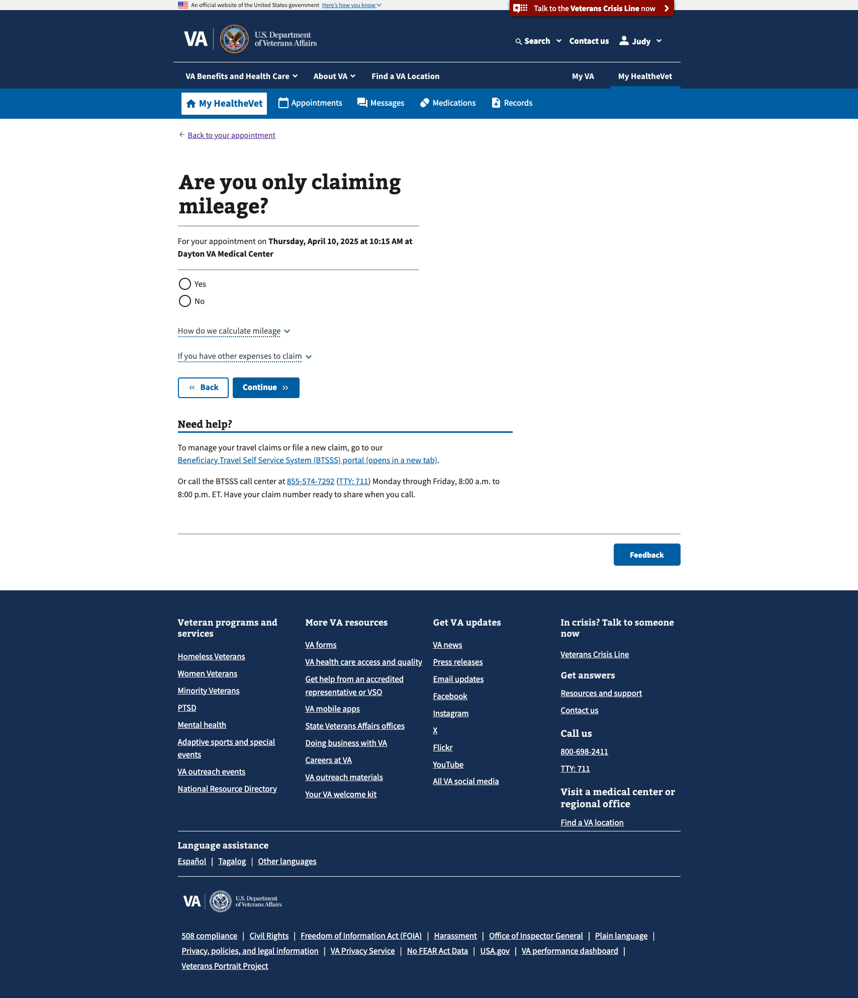

* + Did you travel in your own vehicle?

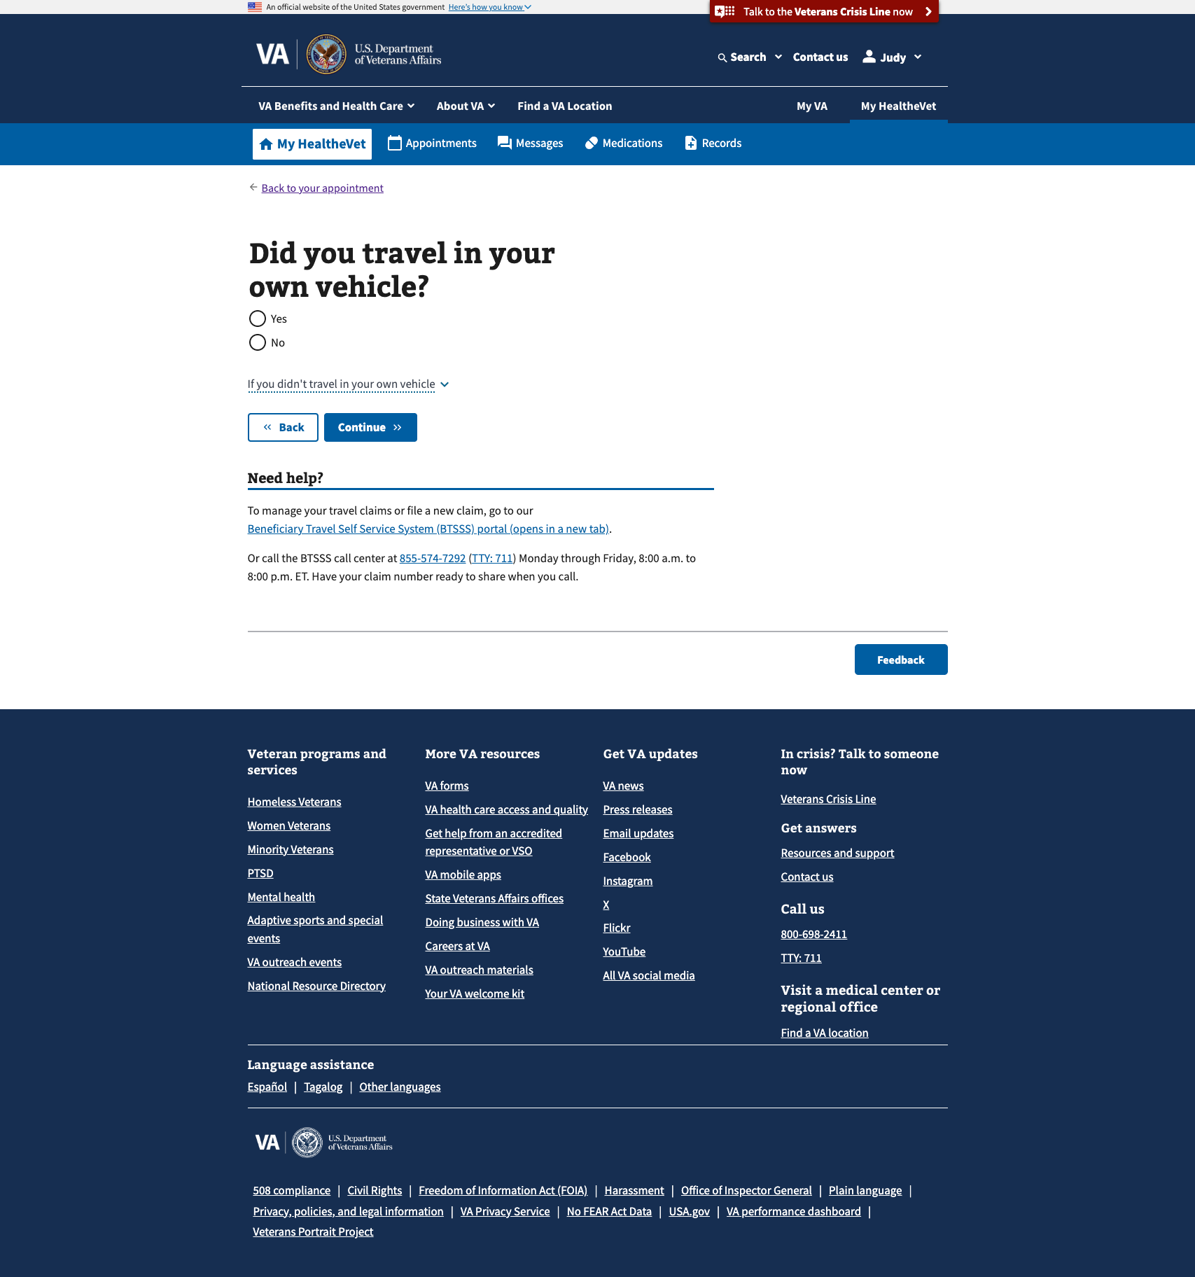

* + Did you travel from your home address?

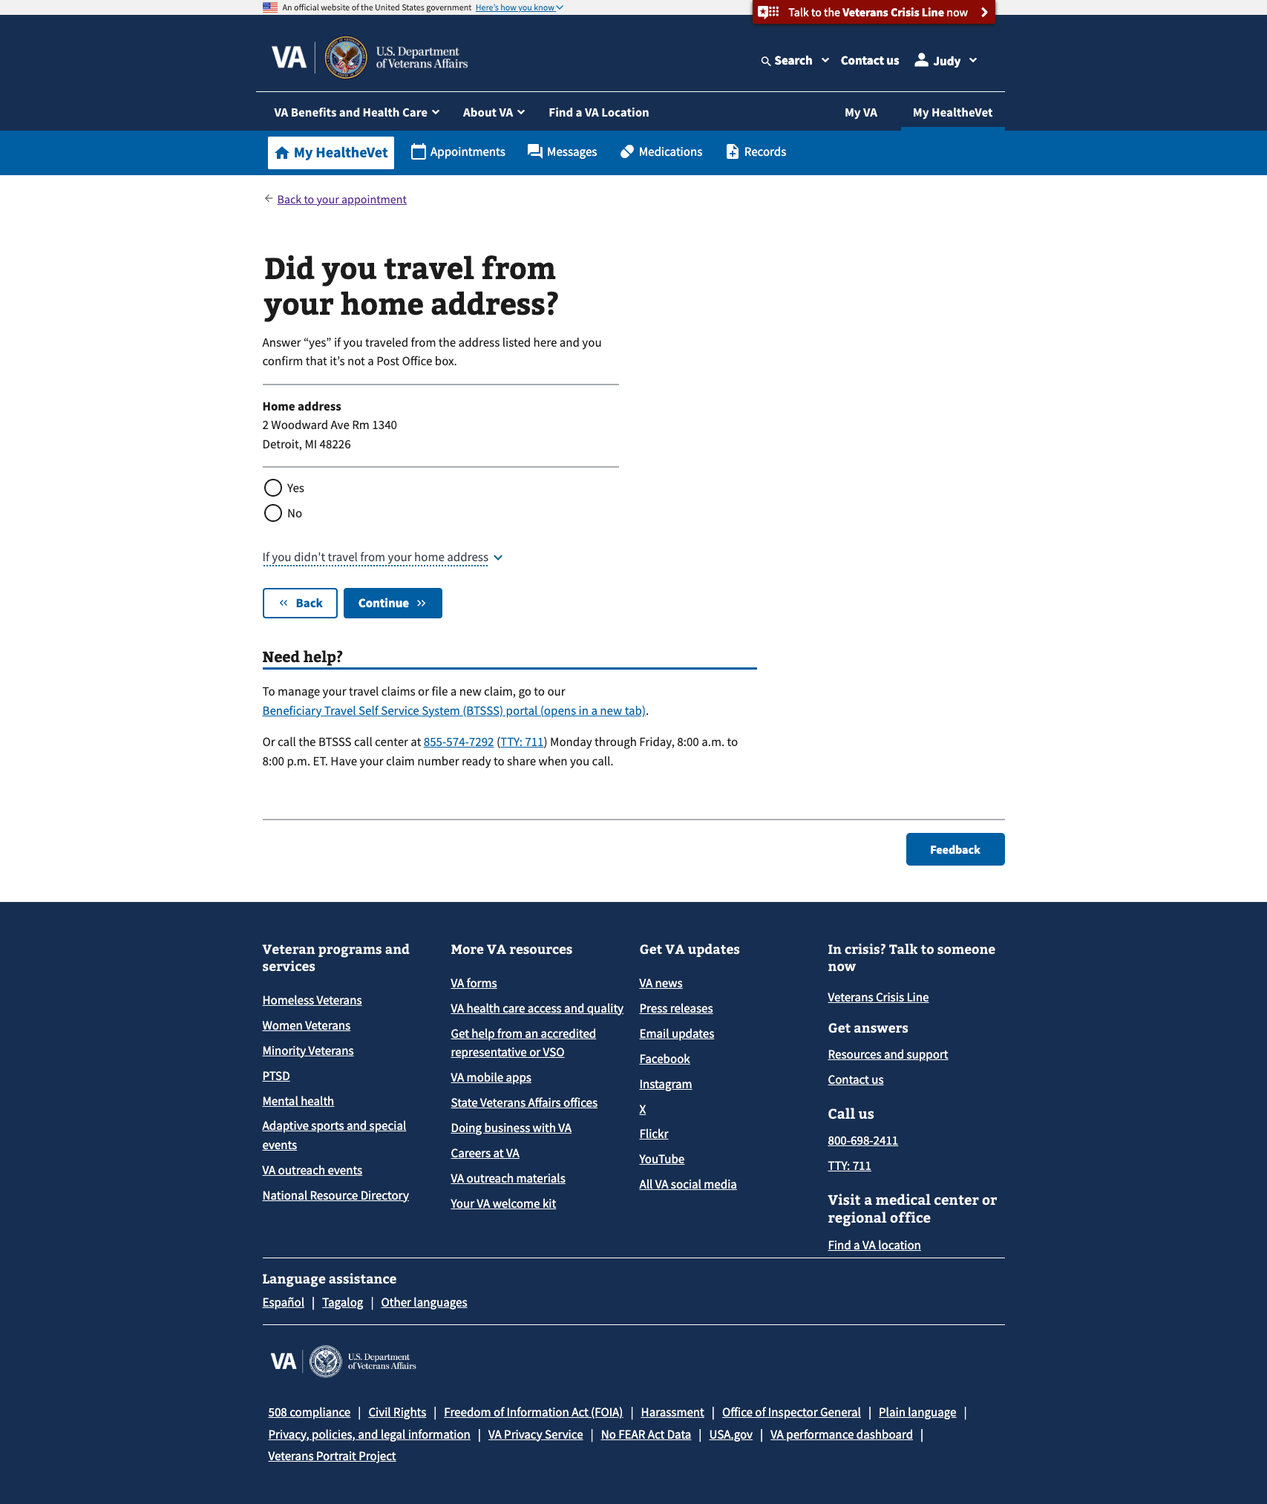

1. If they answer “yes” to all three questions and complete the attestation upon reviewing the travel claim, they can submit for reimbursement for that appointment.

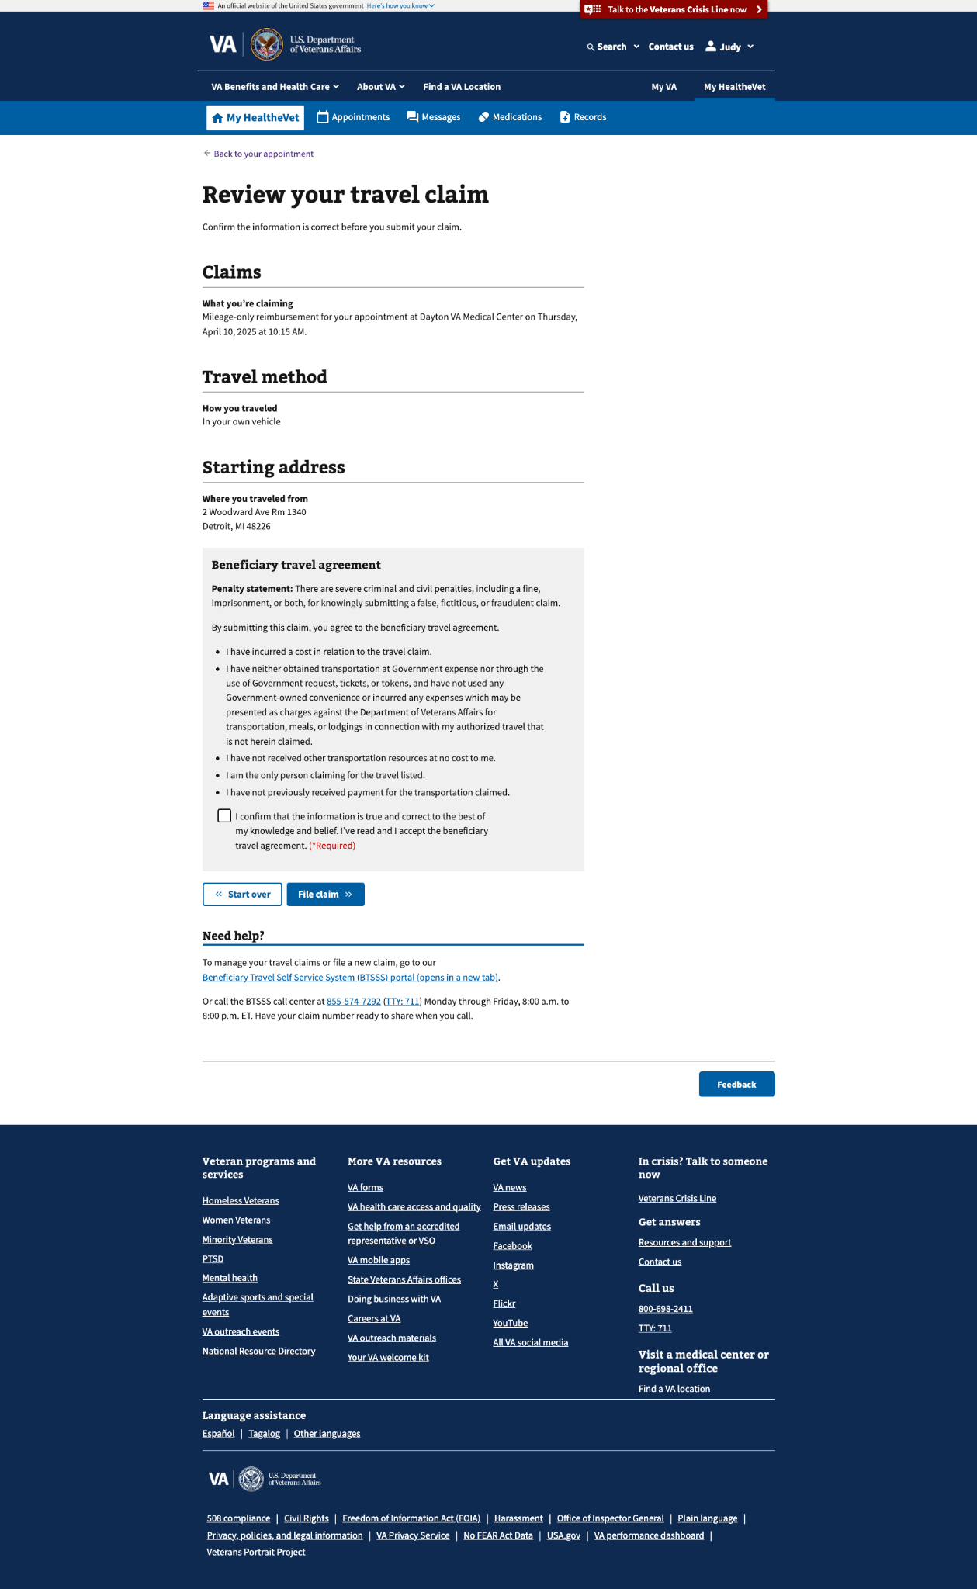

## 5. Major Issues and Error Messages

* **Past 30 day reimbursement window:** Travel claims can only be filed within 30 days of an appointment. Users on VA.gov will get this message when the 30-day window to file for appointments has closed. If they have additional questions, they can click “learn more about reimbursement” or contact the BTSSS call center at 855-574-7292 available Monday through Friday, between 8 am to 8 pm ET.

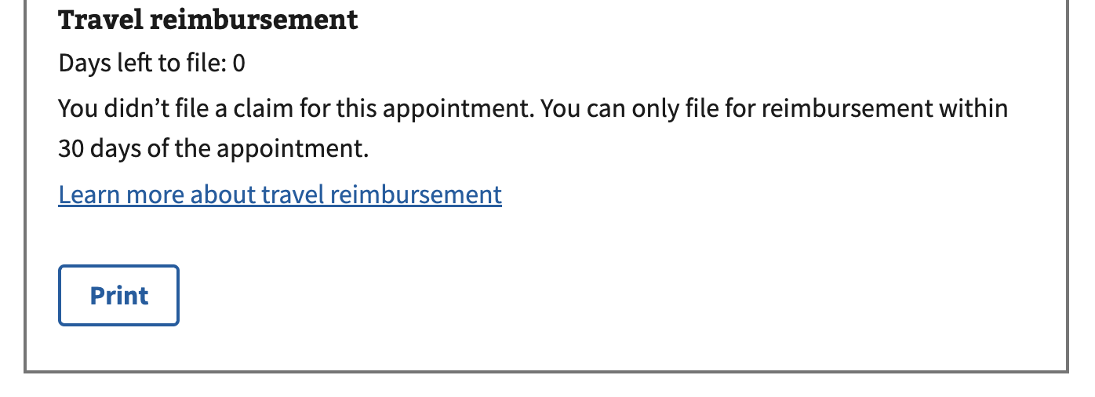

* **No home address in profile:** To file a reimbursement claim, the user must have a home address in their profile to determine the starting address for a simple, mileage-only claim.

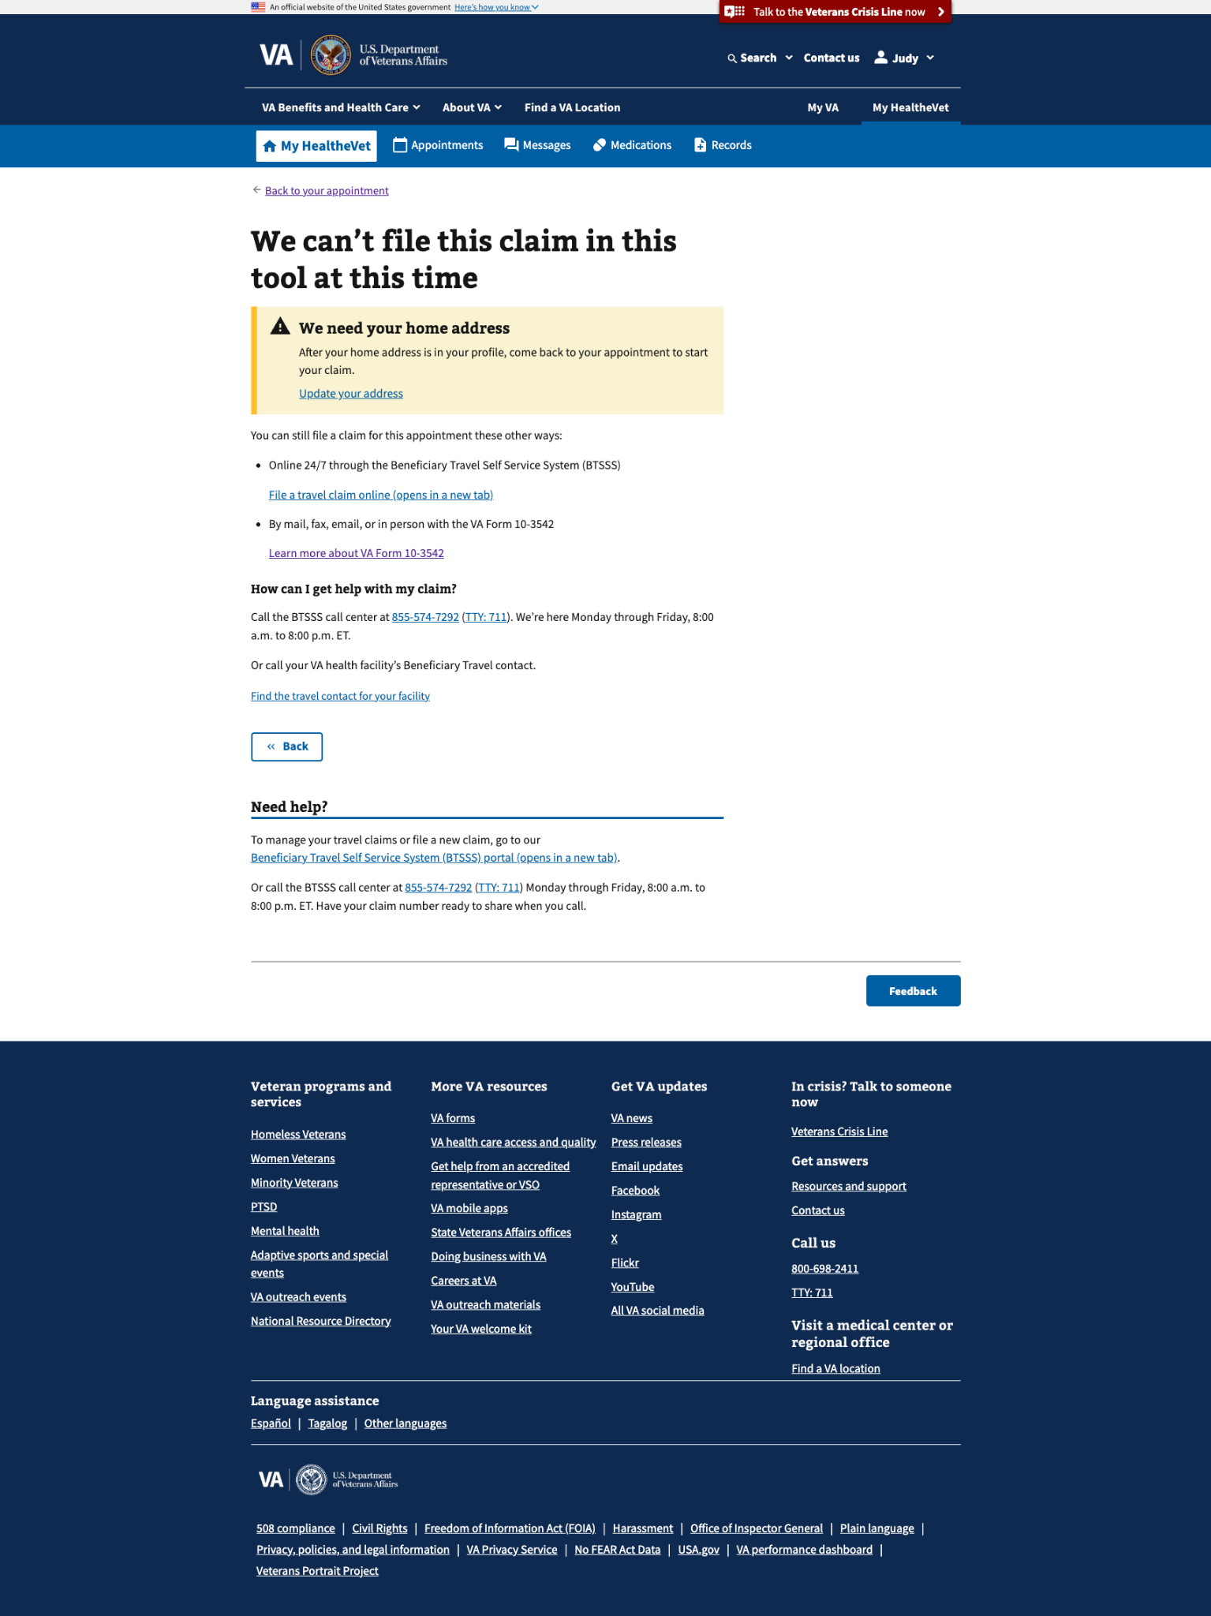

* **Claim not SMOC:** VA.gov currently only supports simple, mileage-only claims. Additional claims, such as those not starting from home address, or with additional expenses, can be filed through the BTSSS portal.
* **General technical error:** Because this is a relatively new product, users may encounter unspecified technical errors. In these cases, we recommend they file through the existing BTSSS portal or contact the BTSSS call center at 855-574-7292 available Monday through Friday, between 8 am to 8 pm ET.

